Analysis of SOLWEIG v2022a (UMEP QGIS plugin)

Week 1
What SOLWEIG is: SOlar and LongWave Environmental Irradiance Geometry, a raster, time-stepping radiation model. Given a 3-D urban surface (buildings, ground, vegetation) + weather, it computes the radiation reaching a person at every pixel and converts it to Mean Radiant Temperature (Tmrt), the dominant driver of outdoor heat stress.
- Spatial unit = one raster pixel (e.g. 1 m or 2 m grid cell).
- Time unit = one row of the meteorological file (one timestep).
- The model is therefore a loop over timesteps, each producing full maps + optional point time-series.

The equation - Per pixel and per timestep, SOLWEIG sums radiation from 6 directions (up, down, N, E, S, W) for shortwave (K) and longwave (L):
Sstr = absK · (Σ shortwave fluxes) + absL · (Σ longwave fluxes)
Tmrt = (Sstr / (absL · σ))^(1/4) − 273.2 [°C]

Symbol | Meaning | Source
Sstr | total radiant flux density absorbed by the human body | blending sun (shortwave, K) and heat (longwave, L) from all 6 directions
σ | Stefan–Boltzmann constant (5.67051e-8) | hard-coded
absK | human shortwave absorption | parameter (default 0.70)
absL | human longwave absorption | parameter (default 0.95)
K↓ K↑ Kside | shortwave fluxes | sun + shadows + albedo + SVF
L↓ L↑ Lside | longwave fluxes | air/surface temp + emissivity + SVF

Two-layer architecture discovered:
Layer | File(s) | Responsibility
Orchestration / GUI | solweig.py, solweig_dialog.* | collect inputs, validate, set defaults, manage thread, write outputs
Physics core | Solweig_2022a_calc.py + SOLWEIGpython/* | one timestep of radiation physics → Tmrt + fluxes

Hierarchical module map
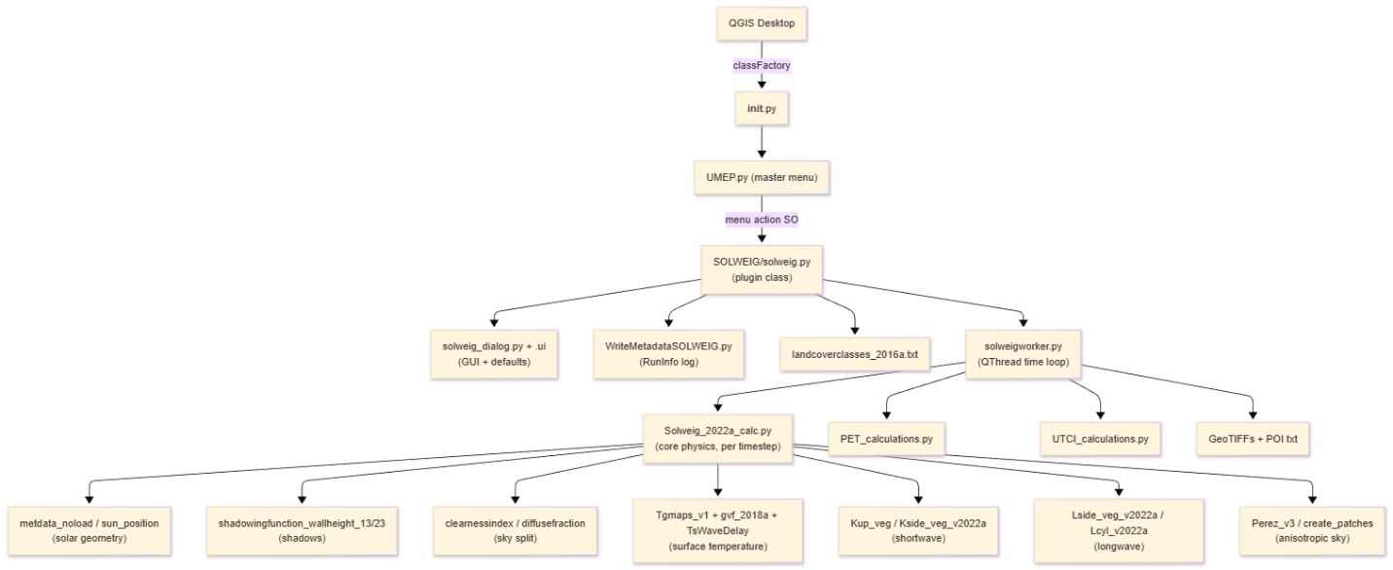
Full file catalogue
Plugin / GUI layer (QGIS-facing) – for application-specific QGIS
File | Role
__init__.py (UMEP root) | QGIS entry point; classFactory(iface)
metadata.txt (UMEP root) | Plugin manifest
UMEP.py | Master menu builder;
SOLWEIG/solweig.py | Plugin class: dialog, raster load/validate, params, threads start point
SOLWEIG/solweig_dialog.py | Loads the Qt Designer UI file – Desktop specific GUI
SOLWEIG/solweig_dialog_base.ui | Dialog layout + default parameter values.
SOLWEIG/WriteMetadataSOLWEIG.py | Writes RunInfoSOLWEIG_*.txt (settings record).
SOLWEIG/landcoverclasses_2016a.txt | LC code → surface thermal/optical properties.
SOLWEIG/tmrt.qml | QGIS style for the average-Tmrt raster.

Compute layer (physics)
File | Role
SOLWEIG/solweigworker.py | Worker (QThread): the timestep loop + output writing
SOLWEIGpython/Solweig_2022a_calc.py | Core model - one timestep: shadows, surface temp, 6-direction K & L, Tmrt.
SOLWEIGpython/Tgmaps_v1.py | per-pixel surface-temperature wave coefficients.
SOLWEIGpython/gvf_2018a.py | Ground View Factors (ground/walls radiating onto a pixel, per direction).
SOLWEIGpython/Kup_veg_2015a.py | Reflected/upward shortwave per direction.
SOLWEIGpython/Kside_veg_v2022a.py | Side shortwave.
SOLWEIGpython/Lside_veg_v2022a.py | Side longwave.
SOLWEIGpython/Lcyl_v2022a.py | Anisotropic longwave.
SOLWEIGpython/cylindric_wedge.py | Wall-shadow fraction seen from a pixel.
SOLWEIGpython/TsWaveDelay_2015a.py | Surface-temperature thermal inertia
SOLWEIGpython/daylen.py | Sunrise/sunset & day length.
SOLWEIG/PET_calculations.py | PET at POIs.
SOLWEIG/UTCI_calculations.py | UTCI at POIs.

Shared utilities (Utilities/SEBESOLWEIGCommonFiles/)
File | Role
Solweig_v2015_metdata_noload.py | Met parsing + sun position, DOY, daily max altitude, default leaf-on flag.
sun_position.py | Astronomical solar geometry.
clearnessindex_2013b.py | Sky clearness index CI (cloudiness proxy).
diffusefraction.py | Splits global radiation into direct + diffuse.
shadowingfunction_wallheight_13/23.py | Shadows (buildings / buildings + vegetation).
Perez_v3.py, create_patches.py | Anisotropic sky patches with relative luminance.

Week2
INPUTS (full spec)
SOLWEIG has three input categories:
- spatial rasters,
- the meteorological file,
- scalar parameters

Spatial raster inputs
Main rule: every raster must share the same extent, resolution, and pixel grid as the DSM, or the run aborts with an error dialog.
# | Input | File type | Unit | Required? | Produced by | Feeds (model use)
1 | DSM - ground + buildings | GeoTIFF | metres | Yes (always) | DSM Generator | shadows, building height, scale, lat/lon, altitude
2 | CDSM -vegetation canopy | GeoTIFF | metres | Optional (veg scheme) | Tree Generator | vegetation shadows, transmissivity psi
3 | TDSM -vegetation trunk zone | GeoTIFF | metres | Optional | Tree Generator or auto = CDSM × trunk-ratio | below-canopy geometry
4 | DEM - bare ground | GeoTIFF | metres | Only if buildings not from land cover | DSM Generator | buildings = DSM − DEM
5 | Land cover grid | GeoTIFF | class code 1–7 | Optional (LC scheme) | Land Cover Reclassifier | per-surface albedo/emissivity/Tg via Tgmaps_v1
6 | Wall height | GeoTIFF | metres | Yes | Wall Height & Aspect | wall longwave/shortwave geometry
7 | Wall aspect | GeoTIFF | degrees 0–360 | Yes | Wall Height & Aspect | direction each wall faces
8 | SVF set svfs.zip | zipped GeoTIFFs | fraction 0–1 | Yes | Sky View Factor Calculator | sky fraction per direction (2.3.2)
9 | Shadow matrices shadowmats.npz | NumPy archive | - | Optional (anisotropic sky) | Sky View Factor Calculator | per-sky-patch shadowing (Perez)
10 | POI point layer | vector (points) | - | Optional | user | locations for PET/UTCI time-series

Contents of svfs.zip
Group | Files | Meaning
Total + cardinal | svf, svfN, svfS, svfE, svfW | sky fraction (building geometry)
Vegetation (sky-blocking) | svfveg, svfNveg, svfSveg, svfEveg, svfWveg | canopy blocking sky
Vegetation (building-blocking) | svfaveg, svfNaveg, svfSaveg, svfEaveg, svfWaveg | canopy blocking buildings
If the vegetation scheme is off, all veg SVFs default to ones (no blocking).
Meteorological input = the 24-column file
Space-delimited text, 1 header row + 24 columns (UMEP "Prepare Existing Data" format). SOLWEIG reads a subset; the rest may be -999.
Col (0-idx) | Name | Used? | Variable | Unit
0 | iy | ✅ | Year | YYYY
1 | id | ✅ | Day of year (DOY) | 1–366
2 | it | ✅ | Hour | 0–23
3 | imin | ✅ | Minute | 0–59
4 | qn | — | Net radiation | W/m²
5 | qh | — | Sensible heat | W/m²
6 | qe | — | Latent heat | W/m²
7 | qs | — | Storage heat | W/m²
8 | qf | — | Anthropogenic heat | W/m²
9 | U | ✅ | Wind speed Ws | m/s
10 | RH | ✅ | Relative humidity | %
11 | Tair | ✅ | Air temperature Ta | °C
12 | pres | ✅ | Pressure P | kPa
13 | rain | — | Rainfall | mm
14 | kdown | ✅ | Global radiation radG | W/m²
15 | snow | — | Snow | mm
16 | ldown | — | Incoming longwave | W/m²
17 | fcld | — | Cloud fraction | —
18 | wuh | — | External water use | —
19 | xsmd | — | Soil moisture | —
20 | lai | — | Leaf area index | —
21 | kdiff | ✅ | Diffuse radiation radD | W/m²
22 | kdir | ✅ | Direct radiation radI | W/m²
23 | wdir | — | Wind direction | °

radD/radI may be -999 only if "Estimate diffuse & direct from global" is ticked.
Ws required only when POIs are used.
A single timestep can be typed in the GUI instead of a file (builds a 1-row version of this array).
Key findings - OUTPUTS (full spec)

Raster outputs (one GeoTIFF per timestep per checked variable)

Filename pattern: Var_YYYY_DOY_HHMM[D|N].tif (D = daytime, N = nighttime)
Output raster | Meaning | Unit | GUI toggle | Day/Night
Tmrt_* | Mean Radiant Temperature (headline) | °C | CheckBoxTmrt | both
Kdown_* | Incoming shortwave | W/m² | CheckBoxKdown | day only
Kup_* | Reflected shortwave (upward) | W/m² | CheckBoxKup | day only
Ldown_* | Incoming longwave | W/m² | CheckBoxLdown | both
Lup_* | Outgoing longwave | W/m² | CheckBoxLup | both
Shadow_* | Shadow map (0 shaded → 1 sunlit) | 0–1 | CheckBoxShadow | day only
Kdiff* | Diffuse shortwave (TreePlanter/Spatial TC) | W/m² | TreePlanter box | day only
Aggregate / auxiliary
File | Meaning | Condition
Tmrt_average.tif | Run-average Tmrt; auto-styled (tmrt.qml), loaded to canvas | "Add to canvas"
buildings.tif | Derived building mask | optional
TDSM.tif | Derived trunk-zone DSM | optional
RunInfoSOLWEIG_*.txt | Full settings record (reproducibility) | always

POI output - the 35-column dictionary
If a POI point layer is selected, each point gets POI_<name>.txt, one row per timestep:
Col | Name | Meaning | Unit
0 | yyyy | Year | YYYY
1 | id | Day of year | DOY
2 | it | Hour | h
3 | imin | Minute | min
4 | dectime | Decimal time | —
5 | altitude | Sun altitude | °
6 | azimuth | Sun azimuth | °
7 | kdir | Direct shortwave (radI) | W/m²
8 | kdiff | Diffuse shortwave (radD) | W/m²
9 | kglobal | Global shortwave (radG) | W/m²
10 | kdown | Incoming shortwave at point | W/m²
11 | kup | Reflected shortwave | W/m²
12–15 | keast, ksouth, kwest, knorth | Shortwave from 4 sides | W/m²
16 | ldown | Incoming longwave | W/m²
17 | lup | Outgoing longwave | W/m²
18–21 | least, lsouth, lwest, lnorth | Longwave from 4 sides | W/m²
22 | Ta | Air temperature | °C
23 | Tg | Ground surface temperature | °C
24 | RH | Relative humidity | %
25 | Esky | Sky emissivity | —
26 | Tmrt | Mean Radiant Temperature | °C
27 | I0 | Extraterrestrial radiation | W/m²
28 | CI | Clearness index | —
29 | Shadow | Shadow flag at point | 0–1
30 | SVF_b | Sky View Factor (buildings) | —
31 | SVF_bv | Sky View Factor (buildings+veg) | —
32 | KsideI | Direct shortwave on cylinder side | W/m²
33 | PET | Physiological Equivalent Temperature | °C
34 | UTCI | Universal Thermal Climate Index | °C
Wind is rescaled by a power law before comfort indices: 1.1 m for PET, 10 m for UTCI.

Input → output influence matrix
✅ = strong/direct effect.
Input / parameter | Tmrt | Kdown | Kup | Ldown | Lup | Shadow | PET/UTCI
DSM geometry | ✅ | ✅ | ✅ | ✅ | ✅ | ✅ | ✅
CDSM / TDSM (vegetation) | ✅ | ✅ | ✅ | ✅ | ✅ | ✅ | ✅
SVF set | ✅ | ✅ | ✅ | ✅ | ✅ |  | ✅
Wall height / aspect | ✅ |  |  | ✅ | ✅ | ✅ | ✅
Land cover (albedo/emis) | ✅ | ✅ | ✅ | ✅ | ✅ |  | ✅
radG / radI / radD | ✅ | ✅ | ✅ |  |  |  | ✅
Ta (air temp) | ✅ |  |  | ✅ | ✅ |  | ✅
RH | ✅ |  |  | ✅ |  |  | ✅
Sun position (DOY/UTC/lat) | ✅ | ✅ | ✅ |  |  | ✅ | ✅
absK / absL | ✅ |  |  |  |  |  | ✅
albedo_b (walls) | ✅ | ✅ | ✅ |  |  |  | ✅
ewall (emissivity) | ✅ |  |  | ✅ | ✅ |  | ✅
Posture (standing/sitting) | ✅ |  |  |  |  |  | ✅
Body model (cube/cylinder) | ✅ |  |  |  |  |  | ✅
Sky model (iso/anisotropic) | ✅ | ✅ |  | ✅ |  |  | ✅
Ws (wind speed) |  |  |  |  |  |  | ✅

Parameters & default values

GUI parameter defaults
Parameter | Default | Range | Used in
Global radiation (manual) | 895 | 1–1300 | single-timestep mode
Air temperature Ta (manual) | 23 °C | -40–50 | single-timestep mode
Relative humidity RH (manual) | 30 % | 1–100 | single-timestep mode
Direct radiation radI (manual) | 810 | 1–1200 | single-timestep mode
Diffuse radiation radD (manual) | 92.5 | 1–600 | single-timestep mode
UTC offset | 1 | -12–12 | sun position
Water temperature | 15 °C | -40–50 | water surfaces
Wind speed Ws | 3.0 m/s | 0.1–60 | PET/UTCI
Sensor height | 10.0 m | ≥0.1 | wind power-law rescale
Vegetation transmissivity trans | 3 % |  | shortwave through canopy
Albedo, walls albedo_b | 0.20 | 0.01–1 | reflections
Albedo, ground albedo_g | 0.15 | 0.01–1 | only if LC scheme off
Emissivity, walls ewall | 0.90 | 0.01–1 | longwave
Emissivity, ground eground | 0.95 | 0.01–1 | only if LC scheme off
Shortwave absorption absK | 0.70 | 0.01–1 | Tmrt
Longwave absorption absL | 0.95 | 0.01–1 | Tmrt
PET body weight | 75 kg |  | PET
PET height | 180 cm |  | PET

Hard-coded defaults
Quantity | Default | Notes
Altitude (site elevation) | median(DSM), else 3 m | for sun calc
Posture Standing | Fside 0.22, Fup 0.06, Fcyl 0.28, h 1.1 m | person↔surface angular factors
Posture Sitting | Fside Fup 0.1667, Fcyl 0.2, h 0.75 m
Stefan–Boltzmann SBC | 5.67051e-8
Veg psi (leaf-off) | 0.5 | transmissivity, no leaves
Leaf-on / off DOY | 97 / 300 | overridden by GUI for deciduous
Surface temp (no LC) | TgK 0.37, Tstart −3.41, TmaxLST 15.0 | cobble-stone-like
Clearness index CI | init 1.0, clamped ≤1 | cloudiness
Sky model default | Isotropic | anisotropic only if Perez ticked
Body model default | Cube | cylinder only if ticked

Land-cover property table (landcoverclasses_2016a.txt)
Name | Code | Albedo | Emis | Ts_deg | Tstart | TmaxLST
Roofs (buildings) | 2 | 0.18 | 0.95 | 0.58 | -9.78 | 15.0
Dark asphalt | 1 | 0.18 | 0.95 | 0.58 | -9.78 | 15.0
Cobble stone | 0 | 0.20 | 0.95 | 0.37 | -3.41 | 15.0
Water | 7 | 0.05 | 0.98 | 0.00 | 0.00 | 12.0
Grass (unmanaged) | 5 | 0.16 | 0.94 | 0.21 | -3.38 | 14.0
Bare soil | 6 | 0.25 | 0.94 | 0.33 | -3.01 | 14.0
Walls | 99 | 0.20 | 0.90 | 0.58 | -3.41 | 15.0

Execution & architecture
Data flow (inputs → model → outputs)
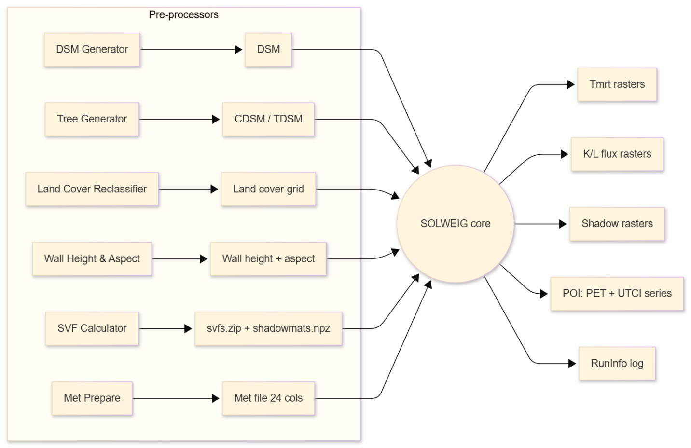
Runtime steps (narrative)
- Load (QGIS startup).
QGIS reads metadata.txt,
calls classFactory in __init__.py → builds UMEP;
UMEP.py adds the menu item.
- Open dialog.
- Collect & validate inputs (start_progress):
read DSM → scale = 1/pixel-size, lat/lon (corner reprojected to WGS84), altitude = median(DSM) (else 3 m)
NoData handling
optional CDSM/TDSM/LC/DEM/walls
extent/resolution check vs DSM
unzip svfs.zip (+ shadowmats.npz if anisotropic, patch count 145/153/306/612).
- Met & solar geometry.
Parse 24-col file Solweig_2015a_metdata_noload → sun position, DOY, daily max altitude.
- Surface-temp maps. LC on → Tgmaps_v1; else uniform defaults.
- Logging. WriteMetadataSOLWEIG.writeRunInfo → settings file.
- Threaded time loop (solweigworker.py): per times

